Mini Game: Obstacle Off-Road
Design Scheme 1.2
directory
- 1. Version history 1
- II. Revision History 1
- III. Overview 2
- 4. Character 2
- V. Map 3
- Camera 14
- 7. Sound Effects 14
- VIII. Fine Arts 14

Version history
File Status:  [√] Draft  [ ] Officially released  [ ] is being modified | File ID:
 | Current version: | 1. 2
 | Author: | Rico
 | Finish Date: | 2022.4.3
Copyright ©KINIX, All Rights Reserved.
Without the written permission of the company, no unit or individual may extract or reproduce this document without authorization
Part or all of the Content may not be disseminated in any form

Revision History
Status: C- Created, A - Added, M - Modified, D - Deleted
serial number | version | date | state | illustrate | author | Reviewer
1 | 1.0 | 20220329 | C | Create a document | Rico
2 | 1.1 | 20220402 | M | Increase lens rules | Rico
3 | 1.2 | 20220403 | M&A | Add a map  Add AI rules  Adjust the description  Add some plans such as sound effects | Rico

overview
            - Game Introduction
Players need to ride forward on the road that stretches forward by riding, while dodging obstacles, and receive trophies according to the order in which they reach the finish line.
            - Rules of the game
- One team per person, for a total of 4 teams;
- 1st place: 5 trophies; 2nd place: 3 trophies; 3rd place: 2 trophies; 4th place: 1 trophy (adjustable);
- If there are still players who have not reached the finish line after the end of the time, all players who have not reached the end point will be ranked in order of distance from nearest to farther away from the end point, and the closer they are, the higher they are;
            - Game Reference
- MachRace: https://store.steampowered.com/app/489100/MachRace/ long straight track, panning left and right to avoid obstacles, focusing on visual performance and highlighting the sense of speed

figure
            - Basic properties
- Bike conversion rate: 1:1 (adjustable).
- Steering rate: real-time
- The player has a collision volume
- Player model size 0.5m (adjustable), using a simple model is sufficient
            - AI rule
- AI speed limit: 35km/h (adjustable).
- AI average speed: 22km/h (adjustable).
- AI behavior logic: keep going to the next AI trajectory point
- animation
  - The characters use a hovering motorcycle, no pedal animation, and the scene resembles the following
  - 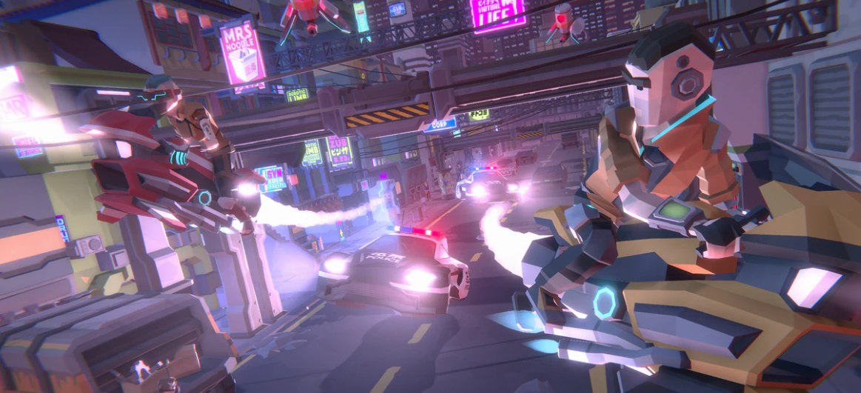

map
            - Map rules
- For the time being, use the Unity static map for fine-tuning
- Has x (landscape) y (portrait) two-dimensional space
- The size of the map refers to a static map, the width is about 10 meters, and it will not pop up if it touches the left and right boundaries
- Map diagram Legend: Yellow Block: Player Spawn Point, Red Block: Trap, Green Block: Accelerator, Blue Block: AI Path Point, Total Size 1 0*1000
- Player spawn point coordinates
  - Y=999
    - X=1,3,6,8
- Trap coordinates
  - Y=959
    - X=0,4,5,9
  - Y=939
    - X=0,4,5,9
  - Y=919
    - X=0,1,4,5,8,9
  - Y=899
    - X=0,1,4,5,8,9
  - Y=879
    - X=0,1,2,3,4
  - Y=859
    - X=5,6,7,8,9
  - Y=839
    - X=0,1,2,3,4
  - Y=819
    - X=5,6,7,8,9
  - Y=799
    - X=0,1,2,3,4
  - Y=779
    - X=5,6,7,8,9
  - Y=719
    - X=0,1,2,7,8,9
  - Y=699
    - X=3,4,5,6
  - Y=679
    - X=7,8,9
  - Y=669
    - X=3,4,5,6
  - Y=659
    - X=0,1,2
  - Y=649
    - X=3,4,5,6
  - Y=639
    - X=7,8,9
  - Y=629
    - X=3,4,5,6
  - Y=619
    - X=0,1,2
  - Y=569
    - X=0,1,2,3,4
  - Y=559
    - X=0,1,2,3,4
  - Y=549
    - X=0,1,2,3,4
  - Y=539
    - X=0,1,2,3,4
  - Y=529
    - X=5,6,7,8,9
  - Y=519
    - X=5,6,7,8,9
  - Y=509
    - X=5,6,7,8,9
  - Y=499
    - X=5,6,7,8,9
  - Y=479
    - X=0,4,5,9
  - Y=459
    - X=0,4,5,9
  - Y=439
    - X=0,1,2,3,6,7,8,9
  - Y=419
    - X=0,1,2
  - Y=399
    - X=7,8,9
  - Y=379
    - X=0,1,2
  - Y=359
    - X=7,8,9
  - Y=339
    - X=3,4,5,6
  - Y=319
    - X=3,4,5,6
  - Y=299
    - X=3,4,5,6
  - Y=279
    - X=3,4,5,6
  - Y=259
    - X=0,1,4,5,6,7,8,9
  - Y=249
    - X=0,1,2,3,4,6,8,9
  - Y=239
    - X=0,1,6,7,8,9
  - Y=229
    - X=0,1,2,3,8,9
  - Y=219
    - X=0,1,6,7,8,9
  - Y=209
    - X=0,1,2,3,8,9
  - Y=189
    - X=0,1,8,9
  - Y=179
    - X=5,6,7,8,9
  - Y=174
    - X=5,6,7,8,9
  - Y=169
    - X=5,6,7,8,9
  - Y=164
    - X=5,6,7,8,9
  - Y=159
    - X=5,6,7,8,9
  - Y=154
    - X=5,6,7,8,9
  - Y=149
    - X=5,6,7,8,9
  - Y=144
    - X=5,6,7,8,9
  - Y=139
    - X=5,6,7,8,9
  - Y=129
    - X=0,1,2,3,4
  - Y=124
    - X=0,1,2,3,4
  - Y=119
    - X=0,1,2,3,4
  - Y=114
    - X=0,1,2,3,4
  - Y=109
    - X=0,1,2,3,4
  - Y=104
    - X=0,1,2,3,4
  - Y=99
    - X=0,1,2,3,4
  - Y=94
    - X=0,1,2,3,4
  - Y=89
    - X=0,1,2,3,4
- Accelerator coordinates
  - Y=759
    - X=0,1,2,3,4,5,6,7,8,9
  - Y=609
    - X=0,1,2,3,4,5,6,7,8,9
  - Y=439
    - X=4,5
  - Y=419
    - X=7,8,9
  - Y=399
    - X=0,1,2
  - Y=379
    - X=7,8,9
  - Y=359
    - X=0,1,2
  - Y=239
    - X=2,3
  - Y=229
    - X=6,7
  - Y=219
    - X=2,3
  - Y=209
    - X=6,7
  - Y=134
    - X=0,1,2,3,4,5,6,7,8,9
  - Y=79
    - X=0,1,2,3,4,5,6,7,8,9
  - Y=59
    - X=0,1,2,3,4,5,6,7,8,9
  - Y=39
    - X=0,1,2,3,4,5,6,7,8,9
  - Y=19
    - X=0,1,2,3,4,5,6,7,8,9
- AI path point (in order).
  - Y=959
    - X=2
  - Y=919
    - X=3
  - Y=899
    - X=3
  - Y=879
    - X=7
  - Y=859
    - X=2
  - Y=839
    - X=7
  - Y=819
    - X=2
  - Y=799
    - X=7
  - Y=779
    - X=2
  - Y=758
    - X=5
  - Y=719
    - X=5
  - Y=699
    - X=8
  - Y=679
    - X=2
  - Y=669
    - X=1
  - Y=659
    - X=7
  - Y=649
    - X=8
  - Y=639
    - X=4
  - Y=629
    - X=8
  - Y=608
    - X=7
  - Y=659
    - X=6
  - Y=539
    - X=6
  - Y=529
    - X=2
  - Y=499
    - X=2
  - Y=479
    - X=2
  - Y=459
    - X=2
  - Y=438
    - X=5
  - Y=419
    - X=4
  - Y=398
    - X=1
  - Y=379
    - X=5
  - Y=358
    - X=1
  - Y=279
    - X=1
  - Y=259
    - X=3
  - Y=249
    - X=7
  - Y=239
    - X=5
  - Y=229
    - X=4
  - Y=219
    - X=4
  - Y=209
    - X=4
  - Y=189
    - X=4
  - Y=179
    - X=3
  - Y=139
    - X=3
  - Y=129
    - X=6
  - Y=78
    - X=6
  - Y=0
    - X=6

            - Trigger element rules
- It can be triggered multiple times, but the same trap can only be triggered once by the same player
- Both sizes are 1*1*1
- Trap triggered after 0 Increase the platform slew rate to 0.7 (adjustable) for 5 seconds (adjustable) and 0.5 seconds (adjustable) for a duration, B After UFF ends the bike table slew rate is from 0.7 to 0. Increased to 1 in 5 seconds 0
- Accelerator triggered after 0 Increase the platform slew rate to 1 in 5 seconds (adjustable). 5 (adjustable), the accelerator lasts 2 seconds (adjustable), and the platform slew rate after Buff ends from 1 5 in 0 Reduced to 1 within 5 seconds (adjustable). 0

camera
- FOV 100 (adjustable) distance (adjustable).
- Speeds above 30km/h (adjustable) appear lens shake, cf. : https://www.youtube.com/watch?v=Smjc9cRPGP4&t=406s This video as a whole is about what aspects of the speed sense of the racing game are reflected, 2-3 minutes The clip is about the effect of lens vibration on the sense of speed.

- Speeds exceeding 3 5km/h (adjustable) Line effects appear, similar to the following effects, which can be replaced by any effect for the time being. After the specific special effects, the art team will do https://www.youtube.com/watch?v=4hlCOUoc6aQ&t=134s

- Motion blur of pavement and surrounding scenes (size is positively correlated with speed, adjustable).
- The FOV briefly becomes larger when the buff is accelerated
- Line effects also appear when boosting buff (regardless of the current speed).

sound effect
- Don't think about it for the time being, find a team to outsource the production after completion

fine arts
- After the mini-game is completed, the settlement screen will pop up a settlement box

